UDC 616.12-008.33:616.132-007.271
BALLOON ANGIOPLASTY FOR NATIVE COARCTATION OF THE AORTA IN INFANTS.

Borodinova O., Maksymenko A., Kuzmenko Y., Kurkevych A.
Ukrainian Children’s Cardiac Center

The issue about BAA options in neonates and infants with native CoA is controversal due to the higher rate of reinterventions (50-83%) in comparison with alternative surgical method. Evaluation of the effectiveness of balloon angioplasty and the rate of recurrent coarctation in infants depending on the age of patients at the time of operation are performed in the article.
The research was performed on the data of 267 consecutive infants who underwent balloon angioplasty for native coarctation at our clinic from January 2007 to December 2014, 116 of these patients were critically ill. The average age of patients was 2,24 ± 2,3 months Hospital mortality rate was 0,7%. Despite good immediate results in 260 patients, risk of reinterventions after BAA in infants is about 57.3%. BAA in infants is radical in 42.7% of cases and allows to postpone cardiac surgery by an average of 88,6 ± 60,7 days. Patients under the age of 2 months have the greatest risk of reinterventions - about 62,3- 64.2% of cases.
BAA is a safe and effective method for treatment infants with CoA with good immediate results. BAA is a safe alternative effective method for treatment infants with CoA over 2 months with relatively low level of reinterventions (about 31-39%).

Key words: coarctation of the aorta, balloon angioplasty of the aorta, infants.

Introduction.
Coarctation of the aorta (CoA) is a congenital cardiac anomaly consisting of a constricted aortic segment (Figure 1), with a prevalence of 5 to 8% of all congenital heart defects (CHD) [1,2]. The classic CoA is located in the segment A of the thoracic aorta distal to the origin of the left subclavian artery (Figure 2.). Typical manifestation of coarctation of the aorta in newborns and infants is acute heart failure that occurs after ductus arteriosus closure. Then there is a progression of pathological changes associated with a high left heart afterload and hypoperfusion of internal organs below the coarctation. It leads to the state decompensation over the next 24 hours since the appearance of first noticeble clinical manufistations. Such critically ill infants account for 10% of children with native CoA, and die in the absence of proper treatment [3].
Balloon angioplasty or surgical correction are the main methods for treatment of native coarctation of the aorta in infants. In Ukrainian clinics the transcatheter approach has become the treatment of choice for children with native coarctation of the aorta, especially for critically ill patients.
 | 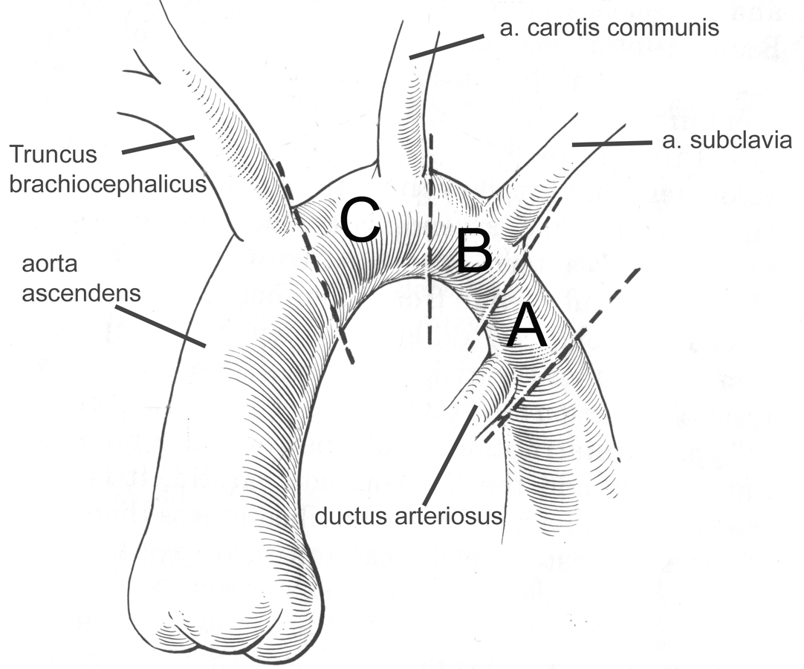
Figure 1. Coarctation of the aorta. | Figure 2. Classification by Celoria & Patton [6]

Purpose.
The aim was to evaluate the effectiveness of balloon angioplasty and the rate of recurrent coarctation in infants depending on the age of patients at the time of operation.
Material and methods.
We reviewed data of 267 consecutive infants who underwent balloon angioplasty for native coarctation at our clinic from January 2007 to December 2014. The average age of patients was 2,24 ± 2,3 months, the average weight - 4,9 ± 1,8 kg.
The clinical characteristics of the circulation have been investigated by echocardiography (echocardiograph Sonos 5500 and 7500 with the 8 and 12 MHz sensors and Phillips iE33 S10-12, S8-3, S5 sensors.). The standard protocol for examination of the heart and aorta was used. The anatomy of the aortic arch was assessed, the degree of the aorta constriction and the presence of hypoplasia of the aortic arch and the peak pressure gradient in the site of CoA were determined. Balloon angioplasty was performed as a diagnostic procedure in patients with a peak pressure gradient of more than 50 mmHg by Echo. BAA was performed in operation room with X-ray angiographic complex Siemens AXIOM Artis II BC. A femoral artery access puncture was performed using pediatric introducer 4F, angiographic wire "Glidewire" .035 Terumo and angiographic catheter "MPA2" 4F (Cordis). Disposable balloncatheter "TYSHAK II" (Numed) with diameter 5-8mm and length 20 mm was used for dilation. The diameter of the balloon corresponded to the aorta diameter directly above the location of CoA. Тhe imaging contrast agent was a radiopaque substance Ultravist - 300 (Shering).
In all cases angiographic X-ray diagnostic procedure was performed (Figure 3) after BAA in order to monitor its effectiveness.
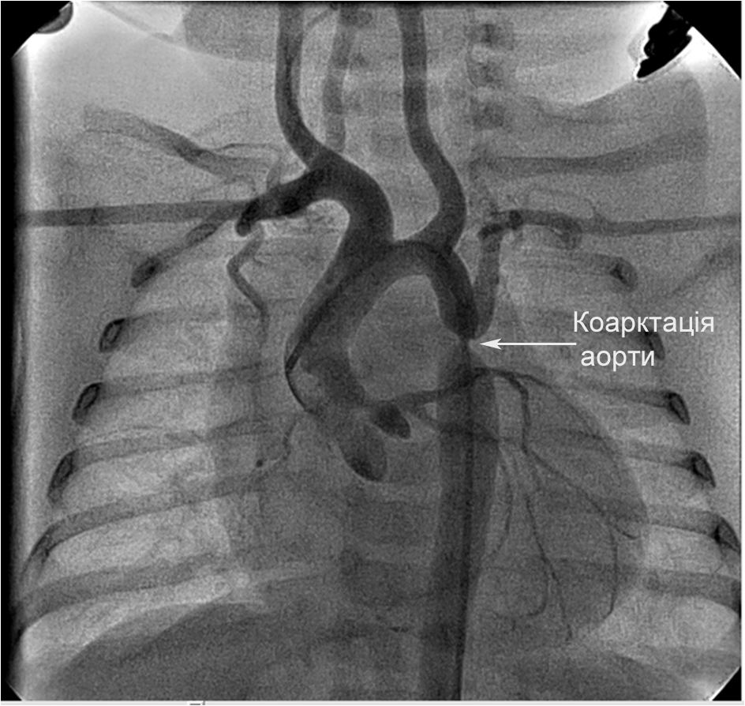 | 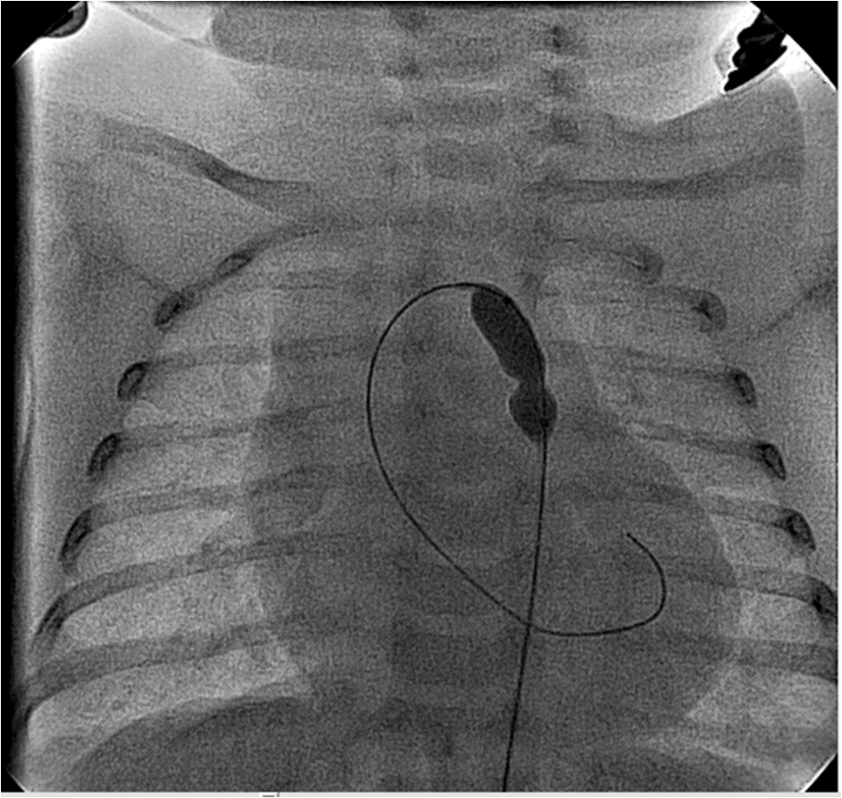 | 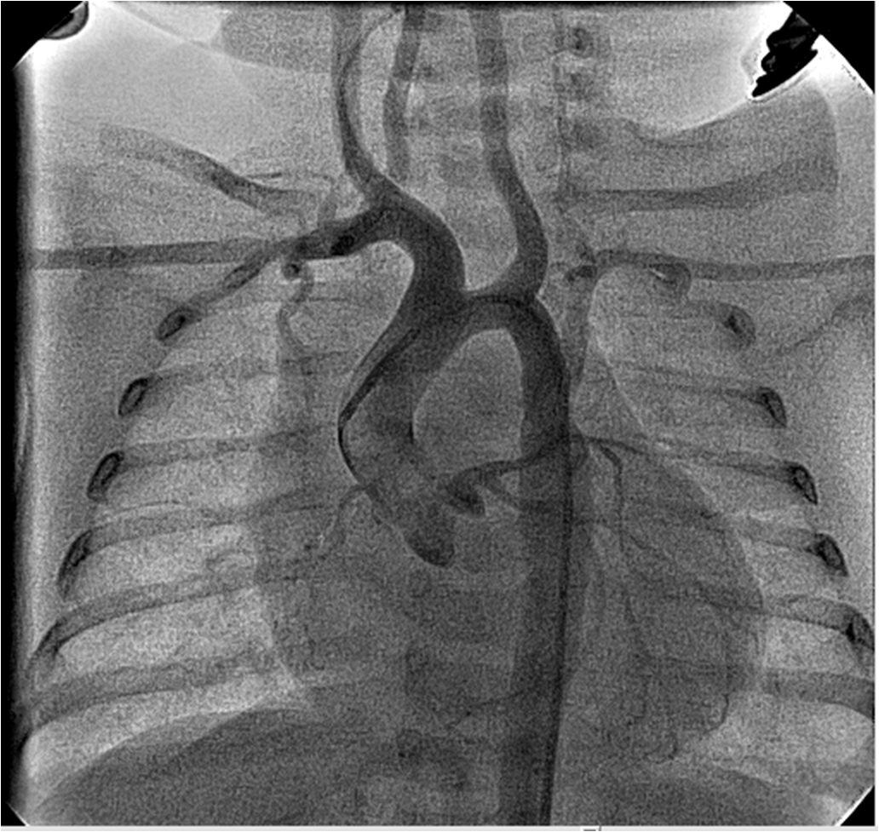
А | b | c
Figure 3. a - X-ray angiography images of CoA in front projection, b - BAA, c - Control aortography.
The main preoperative parameters associated with coarctation of the aorta are shown in Table 1.
Table 1.
The main preoperative parameters associated with coarctation of the aorta.

Parameters | Before BAA
Age (mo.) | ± 22,24 ± 2,3
Weight (kg.) | 4,9 ± 1,8
EF (%) | 51,4 ± 16,4
LV EDI (ml/m²) | 67,6 ± 29,6
Ао desc. (mmHg.) | 52,1 ± 17,6
Bicuspid AV (%) | 69,9%
Critical CoA (%) | 42,0%

These data show that the left ventricular ejection fraction (EF) in children before BAA was an average of 51,4 ± 16,4%, left ventricle end-diastolic index (LV EDI) - 67,6 ± 29,6ml / m2, peak pressure gradient across the descending aorta (Ao desc.) - 52,1 ± 17,6 mmHg. Bicuspid aortic valve (AV) was found in 69.9% of patients. In this group were included patients with critical coarctation, which amounted to 42,0% (n = 116) of all cases. Their hemodynamic abnormalities were associated with high afterload of the left ventricle caused by a high pressure gradient across the descending aorta (51,7 ± 19,2 mmHg). Thus, high afterload led to a decrease in ejection fraction down to an average of 34,7 ± 9,5% and an increase of LV EDI up to 79.6 ± 38,9ml / m2. There was a real hazart to life of these patients who had significant cardiovascular failure and dysfunction of internal organs below the CoA.
The echocardiography was performed to assess the effectiveness of intervention in the early postoperative period and before the hospital discharge. Patients were investigated at 1month, 3mo, 6 mo and 1year after the intervention. Indication for reintervention was a peak pressure gradient higher than 50mmHg by Echo.
After BAA the ejection fraction has increased to 63,3 ± 7,9%, LV EDI - to 77,3 ± 35,5 ml/m2, peak pressure gradient has decreased to 20,5 ± 7,6 mmHg, a pulse on the lower extremities has appeared. Main hemodynamic parameters i.e. heart rate and blood pressure drawn near the physiological norm after BAA. Hospital mortality rate was 0,7% (n = 2); main cause of death in these cases was a secondary multiple organ failure due to the prolonged hypoperfusion of internal organs. The late mortality rate was 0,7% (n = 2). There was no procedure related complications. Five patients (1.8%) needed reintervention during seven days after BAA due to it’s low effectiveness.
The time of follow-up was 2729 ± 2812 days (from 27 days to 7y.). The follow up was received in 95.2% of patients (n = 254), in 13 patients (4.8%) the follow up was lost.
Table 2.
The main echocardiographic parameters in infants after BAA.
Parameters | Before hospital discharge | At the time of follow-up
EF (%) | 63,3 ± 7,9 | 66,8 ± 2,6
LV EDI (ml/m²) | 77,3 ± 35,5 | 57,7 ± 13,3
Ао desc. (mmHg.) | 20,5 ± 7,6 | 19,2 ± 6,4

Despite the high efficacyof BAA, 57,3% (n = 153) of patients reoperation i.e. mainly surgical repair by end-to-end anastomosis (n = 149), four patients required repeated BAA. Average time from BAA to reoperation was 88,6 ± 60,7 days (3 to 771 days). Frequency of reoperations after BAA depending on the age at the time of BAA is presented in Table 3. Most reoperations (from 62 to 64%) were performed in children who underwent BAA during two first months of life. Frequency of reoperations was about 31-39% in children aged over two months. At the time of the last investigation in an average of 2729 ± 2812 days Echo showed an increase in ejection fraction up to 66,8 ± 2,6%, decrease the LV EDI down to 57.3 ± 13.3 mL/m2 and a peak pressure gradient across the descending aorta decrease down to 19,2±6,4.
Frequency of reoperations after BAA depending on the age at the time of surgery.
 | 0-1 mo | 1-2 mo | 2-6 mo | 6 mo-year
Patients after ВАА | 146 | 42 | 51 | 19
Reoperations | 91 | 27 | 20 | 6
% | 62,3 | 64,2 | 39,2 | 31,5

Freedom from reinterventions at one month after BAA was 93.4%, 3 months - 65.6%, 6 months - 55.3% 1 year - 50.9%. (Figure 4.).
Figure 4.
Freedom from reinterventions after BAA in infants.
Discussion.
The first balloon angioplasty for aortic coarctation was performed by Lababidi in 1983y [8], and basically the BAA was offered as an effective treatment of restenosis of CoA in children [9]. But due to the lower complexity of procedure and fewer complications, faster recovery, the BAA is often used for treatment of children with native CoA. In addition, the BAA when necessary provides a significant gain of time. It may postpone a risky surgery in such cases as children in a state of shock and with biliary atresia awaiting liver transplantation and in cases with a severe myocardial dysfunction after spontaneous cerebral hemorrhage,. This method reduces the degree of iatrogenic exposure associated with operating trauma, prolonged anesthesia, mechanical ventilation and massive infusion therapy. When a delay is required or in case of impossibility of urgent surgery, BAA is a fast, safe and effective way to improve the overall state of the patient and prevent life hazard complications.
Nevertheless, the issue about BAA options in neonates and infants with native CoA is controversal due to the higher rate of reinterventions (50-83%) in comparison with alternative surgical method [4,6]. Early development of restenosis after dilatation in infants may be attributed to several factors i.e. the reemergency of ductal elastic tissues that occur in the area of CoA; the hypoplasia of the aortic isthmus, which reduces blood flow in the area of dilatation; the intimal hyperplasia and proliferation of smooth muscle cells [4]. Stenosis after BAA is eliminated by linear breaks of intima and media in the area of CoA [3], which does not exclude the above etiological factors of recoarctation.

According to our data and the literature research, we can made the following conclusions:
1. BAA is a safe and effective method for treatment infants with CoA with good immediate results.
2. Risk of reinterventions after BAA in infants is about 57.3%.
3. BAA in infants is radical in 42.7% of cases and allows to postpone cardiac surgery by an average of 88,6 ± 60,7 days.
4. Patients under the age of 2 months have the greatest risk of reinterventions - about 62,3- 64.2% of cases.
5. BAA is a safe alternative effective method for treatment infants with CoA over 2 months with relatively low level of reinterventions (about 31-39%).

References

      - Arpan R D., Syamasundar R. Coarctation of Aorta-Management Options and Decision Making / Arpan R D., Syamasundar R. // Pediat Therapeut. – 2012. – S5.
      - Mavroudis C., Backer C.L., Pediatric Cardiac Surgery ed.4 – Blackwell Publishing Ltd, 2013. – 256 p.
      - Kirklin/ Barratt-Boyes Cardiac Surgery. – 2004. – Vol. 2. – P. 1321–1352.
      - Andrew C. Fiore, MD, Laurice K. Fischer, MS, Theresa Schwartz, MS. Comparison of Angioplasty and Surgery for Neonatal Aortic Coarctation // Ann Thorac Surg. – 2005. – Vol. 80.– P. 1659–65.
      - Rao P. S., Jureidini S. B., Balfour I. C., Singh G. K., Chen S. C. Severe aortic coarctation in infants less than 3 months: successful palliation by balloon angioplasty // J Invasive Cardiol. – 2003 Apr. – Vol.15 (4). – P. 202–8.
      - Celoria G. C., Patton R. B. Congenital absence of the aortic arch // Am Heart J. – 1959. – Vol. 58. – P. 407−13.
      - Lababidi Z. Neonatal transluminal balloon coarctation angioplasty. Am Heart J. – 1983. – Vol. 106. – P. 752−3.
      - Witsenburg M., The S. H., Bogers A. J., Hess J. Balloon angioplasty for aortic recoarctation in children: initial and follow up results and midterm effect on blood pressure / Witsenburg M., The S. H., Bogers A. J., Hess J. // Br Heart J. – 1993. – Vol. 70. – P. 170−4.
      - Rao P. S., Chopra P. S., Koscik R., Smith P. A. Surgical versus balloon therapy for aortic coarctation in infants ≤ 3 months old. / Rao P. S., Chopra P. S., Koscik R., Smith P. A. / J Am Coll Cardiol. – 1994. – Vol. 23. – P. 1479−83.

