UDC: 616-073. 756. 8+616. 132+616-053. 9
The Role of Multislice Computed Tomography in the Diagnosis of Aortic Arch Pathology (Case Study of Initial Verification of a Complicated Congenital Anomaly in an Elderly Female Patient)

Budzan I.M. ², Sudus A.V. ^{1,2}, Gudzenko T.B. ^{1,2}, Rogiv N.V. ², Nesterak R.V. ^{1,2}, Ivasiuk U.D. ², Stefanskyi O.J. ², Gretchyn O.V. ²

¹SHEI «Ivano- Frankivsk National Medical University» (Ivano- Frankivsk)
²Clinical Medical and Diagnostic Center «SIMEDGRUP» (Ivano- Frankivsk)

The article describes the case of initial diagnosis of an extremely rare congenital aortic arch anomaly in an elderly female patient (age = 79) with the development of esophageal compression and dysphagia symptoms. The role of multislice computed tomography in the verification of the pathology of the thoracic aorta was evaluated.

Keywords: congenital heart disease in adults, vascular ring, multislice computed tomography.

Introduction: Aortic vascular ring as a rare malformation of the aortic arch and its branches is around 1 - 3.8% of the total of all congenital heart disease (CHD) [1,2]. In most cases, this abnormality is diagnosed in childhood, clinical manifestations in the form of severe respiratory obstruction usually occur in the first 6 months after birth and often lead to mortality. The appearance of symptoms after 6 months characterized by easier flow and better prognosis. Surgical correction of this disease usually gives good results [2]. Verification of vascular ring of aorta in adults is extremely rare and the available literature describes few such cases [3,4,5].
The aim of work is to present a rare case of verification of vascular ring of aorta in the elderly patients.
Materials and methods. Patient L., 79-year-old entered to the Diagnostic Center "Simedgrup" for consultation with the diagnosis of cardiac referral: Aneurysm of the thoracic aorta. From the history of the disease is known that two months ago for the first time in life were phenomena of dysphagia, discomfort during swallowing rough and then liquid consistency of food. During the examination, which includes plain radiography of the chest and endoscopy investigation, is suspected pathology of the thoracic aorta as a cause external compression of the esophagus and the consequent effects of dysphagia.
To verify the diagnosis is referred to multislice computed tomography (MSCT) of the chest with contrast. The survey was carried out on the machine which is called Somatom Definition AS, Siemens, Germany, in 2012, a contrast agent - omnipak 350.

Results and discussion. According to the survey (Figure 1) revealed vascular ring formed right sided aortic arch (1 A) and left brachiocephalic artery, or so-called unnamed artery (2 Б). Arch is retroesophageal, along gives right subclavian (3 В), common carotid artery (4 В), continues right sided descending aorta and in the area behind the esophagus forms protrusion or diverticulum Kommerell (5 Г). Unnamed artery departs from the ascending aorta (6 В) is in front of the trachea and esophagus (7 A) [1,2,3,6].
Vascular ring can be complete or incomplete with different options and features [2]. Our case is extremely rare and is the most likely a double aortic arch with atresia of the left component that forms a ring [1,2,3,6].
The feature of this case is the fact that the disease is asymptomatic for a long time and first discovered in old age.

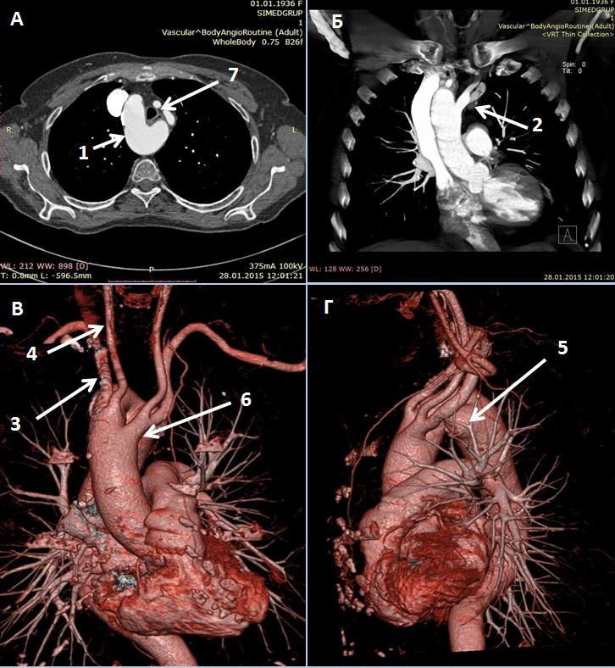
Figure 1. Scans MSCT by patient L., 79 years old.
A - axial projection: 1 – right sided aortic arch. 7 - esophagus (significant compression) and trachea.
Б - front projection: 2 - left brachiocephalic artery.
В and Г - 3D reconstruction of: 3 - right subclavian artery; 4 - right common carotid artery; 5 - Kommerell diverticulum; 6 - origin of the left brachiocephalic artery from the ascending aorta.
Conclusions:
1. MSCT of the chest with contrast is accessible and highly informative method of verification pathology of the thoracic aorta.
2. Complex congenital heart disease can be asymptomatic for a long time and appears in elderly and senile.

References:
- Бураковский В. И. и др. Сердечно-сосудистая хирургия: руководство / Под ред. акад. АМН СССР В. И. Бураковского, проф. Л. А. Бокерия.— М.: Медицина, 1989.—752 с, 328-332с.
- Radiology Cases In Pediatric Emergency Medicine [Електронний ресурс] / Yamamoto LG. Difficulty Breathing Throughout Infancy. In: Yamamoto LG, Inaba AS, DiMauro R (eds), 1999, volume 6, case 19. Available online at: www.hawaii.edu/medicine/pediatrics/pemxray/v6c19.html
- Circulation, Images in Cardiovascular Medicine 2006 [Електронний ресурс] / Hiroshi Ikenouchi, MD; Fumiko Tabei, MD; Nobuhiko Itoh, MD; Akira Nozaki, MD : “Silent Double Aortic Arch Found in an Elderly Man”.
Available online at: http://circ.ahajournals.org/content/114/8/e360
- The National Center for Biotechnology Information; Interactive Cardiovascular Thoracic Surgery 2012 Jun. [Електронний ресурс] /
Kenichiro Noguchi, Daijiro Hori, Yohei Nomura and Hiroyuki Tanaka: “Double aortic arch in an adult”. Available online at: http://www.ncbi.nlm.nih.gov/pmc/articles/PMC3352726/.
- ACCF/AHA/AATS/ACR/ASA/SCA/SCAI/SIR/STS/SVM 2010 Guidelines for the Diagnosis and Management of Patients With Thoracic Aortic Disease / J Am Coll Cardiol. – 2010. – Vol.55. – P. e292.

Будзан Іван Михайлович, м. Івано-Франківськ, вул. Федьковича 91а, клінічний лікувально-діагностичний центр «Сімедгруп», ivan.myhajlovich@gmail.com, (066)1821317.

Роль мультиспиральной компьютерной томографии в диагностике патологии дуги аорты (описание случая первичной верификации сложной врожденной аномалии у пациентки старческого возраста)

Будзан И.М., Судус А.В., Гудзенко Т.Б., Рогив Н.В., Нестерак Р.В., Ивасюк У.Д., Стефанский А.Ю., Гретчин А.В.

В данной статье представлен случай первичной диагностики чрезвычайно редкого врожденного порока дуги аорты у женщины старческого возраста (79 лет) с развитием компрессии пищевода и явлениями дисфагии. Оценена роль мультиспиральной компьютерной томографии в верификации патологии грудной аорты.
Ключевые слова: врожденный порок сердца у взрослых, сосудистое кольцо, мультиспиральная компьютерная томография.

The Role of Multislice Computed Tomography in the Diagnosis of Aortic Arch Pathology (Case Study of Initial Verification of a Complicated Congenital Anomaly in an Elderly Female Patient)

Budzan I.M., Sudus A.V., Gudzenko T.B., Rogiv N.V., Nesterak R.V., Ivasiuk U.D., Stefanskyi O.J., Gretchyn O.V.

The article describes the case of initial diagnosis of an extremely rare congenital aortic arch anomaly in an elderly female patient (age = 79) with the development of esophageal compression and dysphagia symptoms. The role of multislice computed tomography in the verification of the pathology of the thoracic aorta was evaluated.

Keywords: congenital heart disease in adults, vascular ring, multislice computed tomography.

