THE EFFICACY OF FEMORAL-POPLITEAL SEGMENTS ENDOVASCULAR RECANALIZATION IN PATIENTS WITH CRITICAL LIMB ISCHEMIA
Nikonenko A.S., Voloshyn A.N., Materuhin A.N.
Zaporozhye State Medical University
Hospital Surgery Department, Zaporozhye, Ukraine
The overall prevalence of peripheral arterial disease in a range of 3-20% according to international epidemiological studies. Femoral-popliteal segment is the most frequently affected by atherosclerosis arterial segment. In the study, a prospective analysis of the endovascular treatment results of 30 patients with femoral- popliteal occlusion segment. As a result of the treatment in all patients managed to keep the lower limb. Endovascular recanalization the femoral-popliteal segment effective and affordable method of revascularization, allows to achieve good results in the treatment of early postoperative period and promotes more rapid rehabilitation of patients.
Keywords: endovascular recanalization, femoral-popliteal occlusion.
Chronic lower limb ischemia (CLI) is among most common diseases of the circulatory system, and one leading places in the structure of the disability population of industrialized countries [1 - 5]. The number of CLI patients is constantly growing and is estimated 20-25% of all cardiovascular disease in Ukraine [4]. CLI treatment in connection with a steady progression, high risk of amputation and death, as well as the low efficiency of conservative therapy, inevitably requires revascularization. "Gold standard" revascularization for femoral- popliteal segment occlusion until recently remained "open" bypass surgery, but last decade the number of endovascular interventions on the lower extremities arteries has rapidly increased [1,3]. According to TASC 2, with the defeat femoral- popliteal segment of type A and B in 90% of cases, preference is given to endovascular interventions, while 55-85% in lesions such as C and D to open surgery [3,6]. Although the number of endovascular interventions, in femoral- popliteal "stacked" lesions increase [7]. Despite the obvious relevance of endovascular interventions for femoral- popliteal segment in the literature devoted insufficient attention to this problem.
Aim of the study - to evaluate the efficacy of femoral- popliteal endovascular recanalization in patients with critical limb ischemia.
Materials and methods. Analyzed study results of endovascular treatment for 30 patients with femoral- popliteal occlusion. The average age of the patients was 63 ± 3,7 years. Depending on the degree of chronic lower limb ischemia (classification Fonteyn- Pokrovsky) patients were divided as follows: IIB st. ischemia verified in 5 patients, III st. ischemia in 14 and 11 patients with IV st.-. According to the classification TASC 2 the majority of patients had type A and B lesions. All patients was conducted following set: physical examination of the patient, clinical and biochemical blood analysis, the study of lipid metabolism, glucose, ECG, ECHO CS, ultrasound duplex scanning with calculation ankle- brachial index (ABI), digital subtraction angiography . The definition of pain-free walking distance.
In 25 patients were used antegrade transfemoral access under local anesthesia, in 5 patients used retrograde access through the contralateral side, in connection with the transfer of open surgery in the affected side. When using contralateral side access via celebrated a features number and disadvantages in comparison with the antegrade access, since greatly increased the distance to the affected area, which requires elongated conductors use of, special tools, and most importantly, significantly limits for endovascular manipulation, especially in long occlusions. Intraoperative we made systemic heparinization (5,000 IU of heparin) in the postoperative period, all patients received a "double" antiplatelet therapy (aspirin 100 mg + Clopidogrel 75mg). To pass the steno-occlusive disease of the femoral- popliteal segment were used rigid hydrophilic wires 0.035 and 0.014 diameter, supporting catheters 4-5 F and balloon catheters 3-5 mm. Stenosis and occlusion of less than 3 cm length recanalized intraluminaly, occlusion more than 3 cm predominantly subintimal, using 0.014 hydrophilic guide “Roadrunner”. In case of residual stenosis of 50% or more, dissection in the area of ​​atherosclerotic plaque angioplasty, were performed nitinol stent implantation, self-extracting stents preference, however, in 3 cases at least 1 cm occlusion were implanted ballon stent.
Results and discussion. As a comprehensive treatment results for all patients managed to keep the lower limb. During the endovascular intervention not been any complications that would require surgical correction. Three patients has hematoma in puncture site, that decided after a short compression. Six patients after femoral-popliteal angioplasty originated atherosclerotic plaque dissection, which required nitinol stent implantation. In one case, on the second day after endovascular recanalization with femoral artery stenting, there was an lower limb acute ischemia, which required urgent surgery. After femoral-popliteal thrombectomy restored peripheral pulsation, in follow-up period for 6 months retrombosis noted. For a better nature understanding and effectiveness CLI current endovascular recanalization, give a clinical example.
Patient I., born in 1958, with chronic segmental occlusion of the right superficial femoral (up to 2 cm.). CLI 4 stage. ABI = 0.49. According to the classification TASC 2 defeat Type A (Figure 1 A) on the operation used antegrade femoral access. Occlusion zone passed transluminally 0,014 hydrophilic guidewire. Then performed femoral artery balloon angioplasty with a 3 min exposure. Control angiography (Figure 1B), there is a femoral artery residual stenosis up to 65%. The next step is executed implantation self-expanding nitinol stent in the area of ​​stenosis (Fig.1C). The total duration of the intervention was 35 minutes.
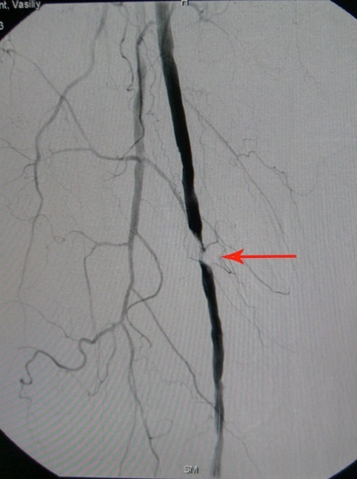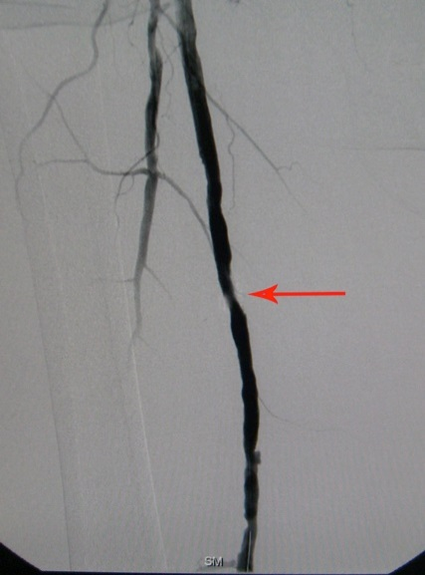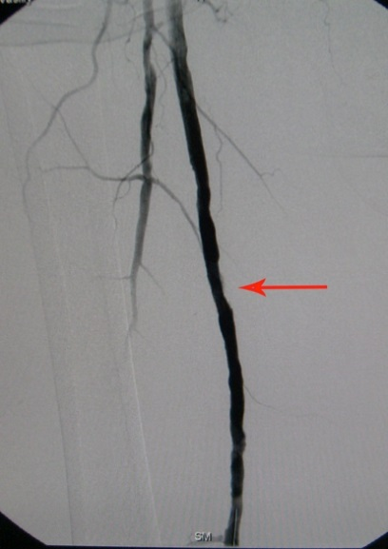
A. B. C.
Figure 1. A. Segmental right femoral artery occlusion up to 2 cm; B. Residual 65% femoral artery stenosis following angioplasty; B. Self-expanding stent implantation in the area of residual stenosis.
After endovascular surgery, in patient completely was eliminated pain syndrome, increased pain-free distance up to 150m., trophic ulcer began to actively granulated. ABI increased up to 0.82. After 6 months in ultrasound control stent implantation area, there is no hemodynamically significant stenoses, and trophic ulcer completely healed.
In early postoperative period, all patients were in general ward and the average length of hospital stay was 6 ± 2 days. The median ABI alone according ultrasound duplex increased from the initial 0.37 to 0.67. During the control of duplex ultrasonography in all patients registered with the normalization of peak systolic velocity in the zone of recanalization. Five patients with an initial 4 degree CLI in 6 months. after angioplasty, fully healed sores and pain-free walking distance increased.
For today, despite the relatively successful use of endovascular femoral-popliteal recanalization, the number of intraoperative complications such as dissection or plaque dissection with distal embolization are frequent enough. Femoral-popliteal segment is the most frequently affected arterial segment by atherosclerosis, it is characterized by long, diffuse stenosis and occlusion with a relatively slow blood flow and high resistance. Anatomy of the femoral and popliteal arteries are extremely complicated, since they are exposed to impacts in different directions during limb movement. These arteries not only compressed, bent and rotated, but also shorten and stretch in response to flexion and limbs extension [8]. These factors have a negative impact on long-term results of endovascular interventions. According to a Schillenger M. survey, lesion length at 5 cm three year patency of an artery following angioplasty, endovascular averaged 72%, from 5 to 10 cm and more than -59% 10 cm - 30%. Several randomized trials have shown the long-term half amount of restenosis after stenting compared with angioplasty, but this difference was shown in patients with lesions greater than 5 cm [9]. On this basis, there is need for further research on patients treatment with atherosclerotic femoral-popliteal lesions by comparing open surgery and endovascular interventions.
Conclusions:
1. Femoral-popliteal endovascular recanalization effective and affordable method of revascularization, allows to achieve good results treatment in early postoperative period and promotes more rapid patients rehabilitation.
2. International Classification of TASC II, helps to choose the best way to restore patency of femoral-popliteal segment in patients with critical lower limb ischemia but requires a revision and expansion of indications in the direction for endovascular interventions.
3. Femoral-popliteal endovascular recanalization preferred antegrade transfemoral access, which allows you to apply a wider range of interventions for revascularization.
References:
- TASC. Management of Peripheral Arterial Disease (PAD) TransAtlantic Intersociety Consensus (TASC). J Vasc Surg 2000;31(1 part 2):S1eS287.
- Hirsch A.T. "The global pandemic of peripheral artery disease" The Lancet, Volume 382, Issue 9901, Pages 1312 - 1314, 19 October 2013.
- L. Norgren, W.R. Hiatt, et al. Inter-Society Consensus for the Management of Peripheral Arterial Disease (TASC II) Eur J Vasc Endovasc Surg 33, S1eS75 (2007).
- Сморжевський В. Й. Хірургічне лікування поєднаних атеросклеротичних уражень магістральних артерій нижніх кінцівок та серця: дис. д-ра мед. наук / В. И. Сморжевський. - К., 2002. - 26 с.
- Gardner A.W., Parker D.E. Gender differences in daily ambulatory activity patterns in patients with intermittent claudication. J. Vasc. Surg. 2010; 52:5:4-10.
- McCann AB, Jaff MR. Treatment strategies for peripheral artery disease. Expert Opin Pharmacother. 2009 Jul;10(10):1571-86.
- Olin JW, Sealove BA. Peripheral artery disease: current insight into the disease and its diagnosis and management. Mayo Clin Proc. 2010 Jul;85(7):678-92.
- Schillinger M. Past, present and future of femoropopliteal stenting / M. Schillinger, E. Minar // J Endovasc Ther. — 2009. — Vol. 16. Suppl I. — P. I-147–I-152.
- Shouse H.B. Biomechanical forces in the femoropopliteal arterial segment / H. B. Shouse, A. Nikanorov, D. LaFlash // Endovascular Today. — 2005. — No 4. — P. 60–66.

