Treatment of patients with transposition of great arteries and additional aorto-pulmonary collateral arteries.

Baklan KA, Chernyshuk SS, Maksimenko AV,
Zhovnir VA Yemets IM

GI "The Scientific-Practical Children’s Cardiac Center"
TheMinistry of Health Care of Ukraine (Kyiv)

The current level of cardiac surgery allows us to perfom one stage surgical correction of complex congenital heart disease at an early age. After cardiac surgery may be presence of residual pathology. Usually complicated postoperative period increases the risk of cardiac and respiratory failure, manifestation of infectious processes and so on. We describe a case of treating a patient after surgery arterial switch, in which were found abnormally enlarged bronchial arteries. Endovascular closure one of these vessels was necessary to improve the patient's condition.

Keywords
Congenital heart disease, transposition of the great arteries, arterial switch operation, aorto-pulmonary collaterals.

Case report
A 10-days-old infant was admitted to the GI "SPCCC" with diagnoses: transposition of great arteries (TGA) with intact ventricular septum, patent foramen ovale (11mm) and persistent ductus arteriosus (5mm). At the time of admission the child's condition was satisfactory, blood oxygen saturation ranged from 61% to 66%. The child was started on prostaglandin E1 in standard dose (10 ng / kg / min). The operation was postponed, because we detected cerebral hemorrhage by MRI at the time of admission. In 19 days of life the child performed the operation arterial switch. The operation was no features: a cross-clamp time 67 minutes bypass - 122 minutes. The child was transported to the intensive care unit with standard inotropic support (dopamine - 5 mcg / kg / min). At the target echocardiography was founded decreased left ventricular contractility, so it was decided to appoint Levosimendan at a dose of 0.1 mcg / kg / min. After 48 hours of satisfactory contractility of the heart and blood gas, the child was extubated. On the planned X-ray was discovered eclipse in upper right lobe of lung. During 8 days carried out planning non-invasive ventilation. The condition of lungs is not improved, oxygen saturation of arterial blood with air breathing was lower than 85%. We had the signs of respiratory failure and the needed for sanitation tracheobronchial tree therefore child was intubated. On chest X-ray marked improvement, but when we tried to extubate the patient, the X-ray image acquired previous view (eclipse in upper right lobe of lung) (Figure 1). In conducting echocardiography was visualized the vessel diameter of 2 mm, which departed from the aortic arch. Given the results echocardiography and ineffective conservative treatment, it was decided to hold angiogram. A subsequent angiogram showed two bronchial arteries. First artery diameter of 2 mm arising from the distal descending aorta and partly supplied the right lung (Figure 2). Second bronchial artery diameter about 1.3 mm partially supplied left lung. Coil embolisation was carried out of the first bronchial artery with Boston Scientific Complex Helical Fibered Platinum Coil- 2x10 mm 18 number 3 (Figure 3). At the control angiography visualized complete occlusion of the vessel. The next day the child was able to extubate (Figure. 4). On the 4th day the child was transferred to cardiology department in satisfactory condition.
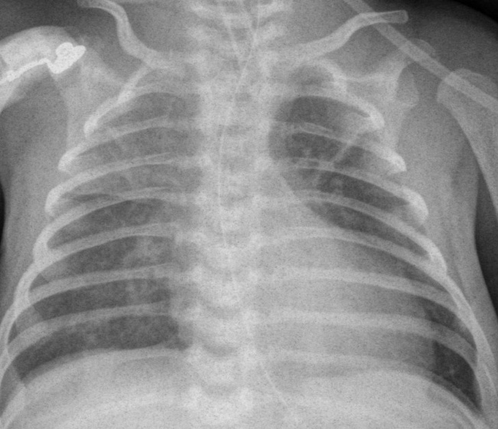
Figure. 1. Eclipse in upper right lobe of lung. The patient was intubated.

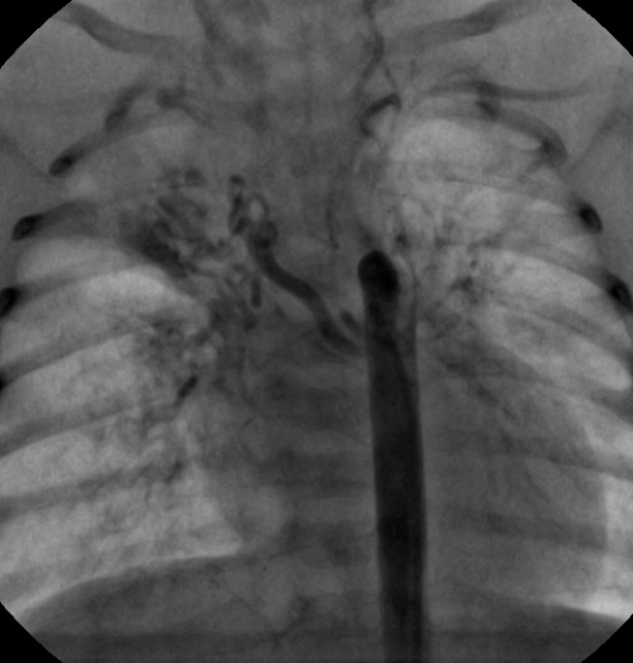
Figure. 2. Anomaly enlarged bronchial collateral artery which supplied the right lung.

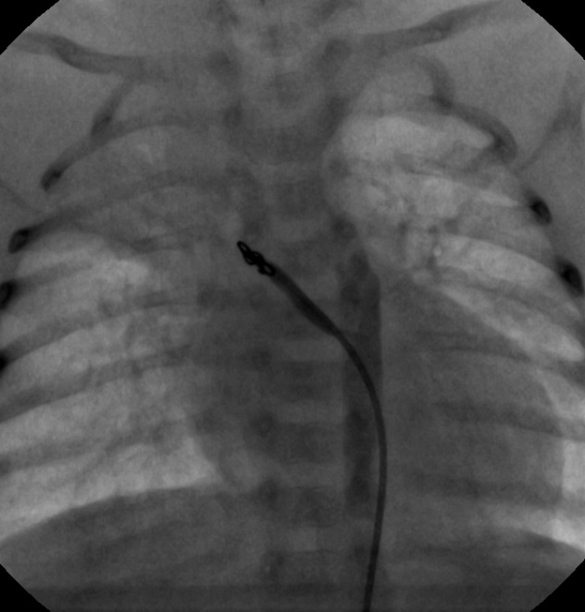
Figure. 3. Angiographic appearance after coil embolisation

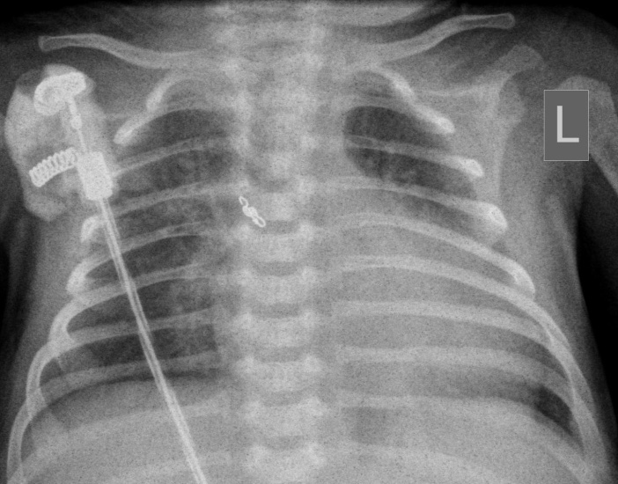
Figure. 4. The X-ray before the patient was transferred to cardiology department.

Discussion
Abnormal increase in bronchial arteries often occurs in patients after surgery arterial switch [1]. According Wernovsky G et al. [2] of 119 patients operated on transposition of great arteries from 1983 to 1991, which planned angiographic examination was performed. In 55 (46%) patients found one or more abnormally enlarged bronchial arteries. Vascular embolization was performed in five (9%) of 55 patients.
Currently cause an increase in bronchial arteries is unknown. According to some reports, these vessels develop on the time which the surgery was postponed [4].
In the preoperative stage the enlarged bronchial arteries may not be essential or collateral artery can masked in this scenario by the presence of a patent ductus arteriosus (PDA) [6] [8]. Standard angiographic examination at the stage of balloon atrioseptostomy may not always give an opportunity to identify additional collateral vessels.
Late diagnosis and delayed closure of these vessels can lead to the development of complications such as emphysema, pulmonary hypertension [4], due to hyperperfusion some parts of the lungs, and can worsen the condition of the child because of possible stealing systemic circulation and increased preload on the left ventricle. However, an abnormal enlarged bronchial arteries may not lead to deterioration of the patient.
In the presence of the patient's respiratory failure after arterial switch operation, primarily to exclude inflammation and possible damage to the lungs after using lung machine, TRALI, infection. Preterm patients the prolonged stay in the intensive care unit may be immature lung tissue and lack of surfactant. If these factors were excluded, and after correction of defects present the following clinical signs:
1) the need for prolonged mechanical ventilation [3]
2) arterial oxygen saturation <85% [3]
3) the echocardiography view the increase heart chambers [7] and impaired myocardial contractility [5]
4) needed for long-term inotropic support [6]
it can be considered grounds for angiographic examination of the patient to exclude significant residual disease, including - aorto-pulmonary collaterals.
Long stay in the ICU and ineffective conservative treatment has enabled us to suspect the presence of enlarged bronchial artery, to hold the vessel embolization, and prescribe the patient.

References
- Santoro G, Carrozza M, Russo MG, Calabrò R. Symptomatic aorto-pulmonary collaterals early after arterial switch operation. Pediatr Cardiol. 2008;29:838–41. [1]
- Wernovsky G, Bridges ND, Mandell VS, Castaneda AR, Perry SB. Enlarged bronchial arteries after early repair of transposition of the great arteries. J Am Coll Cardiol 1993;21:465-70.[2]
- Navarini S., Balmer Ch., Hug M., Dave H., Prêtre R., Kretschmar O., Knirsch W. «Aortopulmonary collaterals in neonates with d-transposition of the great arteries (d-TGA) – clinical significance after arterial switch operation» Division of Pediatric Cardiology, University Children's Hospital, Zurich, Switzerland [3]
- Aghaji MA, Friedberg DZ, Burlingame MW, Litwin SB. «Hypoxemia and pulmonary hyperperfusion due to systemic collateral arteries after total repair of transposition of the great arteries.» 1989;30:338–41. [4]
- Saileela, R., Shanthi, C., Manohar, K., Subramanyan, R., & Cherian, K. (2012). Myocardial ischemia following arterial switch operation: An uncommon etiology.Annals of Pediatric Cardiology, 5(2), 194–196. doi:10.4103/0974-2069.99626 [5]
- Irving C, Chaudhari M. Enlarged bronchial collateral artery complicating recovery after arterial switch for simple transposition of the great arteries. Interact Cardiovasc Thorac Surg. 2008;7:1176–7 [6]
- S Raja, S Nayak, M Kaarne, «Arterial Switch Operation for Simple Transposition: Three Decades Later» The Internet Journal of Thoracic and Cardiovascular Surgery. 2003 Volume 6 Number 2. [7]
- V Jowett, Graham D, V. Tsang, Jan Marek, «Coil Occlusion of Aortopulmonary Collateral Arteries Before Arterial Switch Procedure in an Infant With Transposition of the Great Arteries» Circ Cardiovasc Imaging. 2008;1:e17-e18 [8]

